Suggested Age Range: 7 - 8 years; 8 - 9 years; 9 - 10 years; 10 - 11 years; Adult;
UK Curriculum: Key Stage Two (Lower); Key Stage Two (Upper);
Suggested UK Year Groups: Year Three, Year Five
UK Primary Curriculum Links: Light; Earth and Space; States of Matter
Science Subject: The Moon
Science Questions: Why Does the Moon change shape? What are Stars?
Suggested Science Activity: Phases of the Moon; Star Crowns; Star Maps
Children with SEND: Use to boost comprehension of science vocabulary
EAL children: For intermediate learners
Country of Origin: China and Japan
Source: Tale told by members of Chinese community in Birmingham, 1991

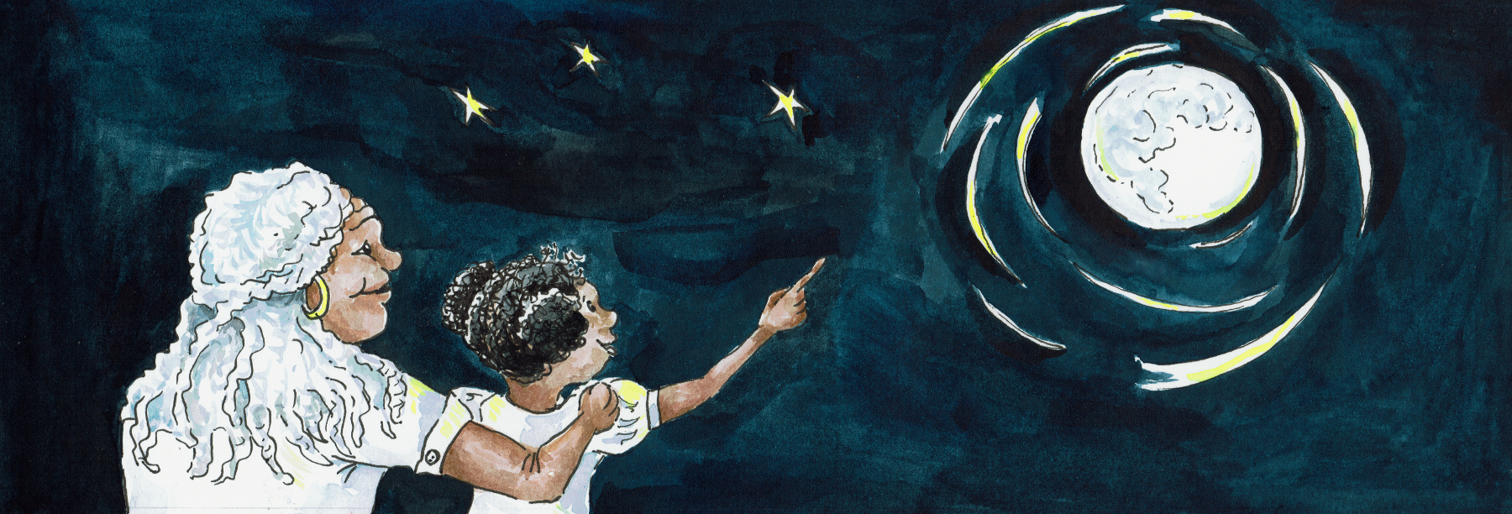
Long ago, the Father of the Sky still lived with the Gods and Goddesses in the Heavens. And he ruled both the Earth and the Sky, with power over all people, both mortal and immortal. The Father of the Sky had just one child, a daughter.

And her task was to weave the fabric of the Sky into life both day and night.

It was she … who wove the clouds and the silken sound of rain.
It was she … who stitched the Sun that shone across the sky.
It was she … who embroidered the sky with shining streaks of lightening

And she worked all day and all night. She never took, not even a single moment to rest, for she was an immortal and needed no sleep. The Gods and Goddesses loved her and wanted her to spend time with them, enjoying the gifts of the Heavens.

But - she could never be persuaded to leave her loom.

Some even asked her to marry them. But she always refused, saying that her Father needed her more than they did. Besides - she was always too busy weaving to think about marriage.The Earth needed her to make the sunshine and the rainfall, so that all that lived on the Earth could thrive. The Gods and Goddesses went to her Father to plead with him, to make her stop for a while. And her father realised that they were right. He went to his daughter and said: “Spend a day down on Earth.”

“Take time to stop and appreciate what you have made”.
“Take time to see your raindrops dancing on the petals.”
“Take time to bask in the warmth of your sun.”

And his dutiful daughter did as he asked.And in truth, she was glad to do so.
For you see, whilst her hands were busy weaving, her ears had been busy listening..

She had heard the sound of music, beautiful music floating up from the Earth and she was curious to know - who made such a beautiful sound?
And so she drifted down to Earth on a Moon-beam, following that sound.

She landed in the corner of a rice field, where a buffalo was hitched to a plough and was slowly making his way across the field. And the boy herding the Buffalo was playing a small wooden flute to encourage the Buffalo on his muddy path.

This was the sound she had heard! Such a beautiful sound!
And beautiful too was the boy who was playing the flute!
She watched and listened entranced.

And as the buffalo came to a halt and slowly turned to go back across the field once more, the Buffalo Boy looked up and out of the corner of his eye, he saw her!

And he stopped still, his mouth open with astonishment!
For there stood the most beautiful girl he had ever seen!
With hair the colour of midnight sky and eyes as brown as the Earth.

The two of them spent the afternoon together, under the shade of a tree. And that night, when it was time for her to return to the Heavens, she went straight to her father.

“I have found the one I will marry” she said. And she told him about the Buffalo boy.
“But he is a son of the Earth and you are a daughter of the Heavens!” said her father “How can you marry?’

“Father, you must choose. Either I will leave here and live upon the Earth and weave no more. Or else, he must join me in the Heavens. But we will remain together.”

And so her father chose to make the boy immortal and he came to live in the Heavens, along with his Buffalo.
And on their wedding day, the sun shone through the sparkling dancing rain, and the very first rainbow stretched across the Sky.

But …
The young wife spent so much time with her wonderful husband, that she grew forgetful of her work. And he too made any excuse to leave his Buffalo to spend time with his wife.

So her loom stood still. No rain fell, no sun rose, and the Earth was covered in darkness.

Time and time again her father reminded her of her duty, her life’s work. And she would promise to do better. But again and again she forgot her promises, as she wandered off with her husband. Until at last the Father of the Sky grew angry.

“You two must live apart so that life on Earth can resume.”

And so he created a river across the sky, what we now call the Milky Way, and placed her on one side and him on the other. And so they were parted forever.

She went back to her loom. And cried, cried as if her heart would break.
And cried until her tears were woven into the very fabric of the Earth.

Floods descended upon the lands below. The people on Earth begged the Father of the Sky to find a way to stop the floods. And so he relented.

“On the seven night of the seventh Moon, for one night and one night only, you two shall be together. But only if both of you continue your work!”

And so, with something to look forward to, she dried her eyes.
And on the seventh night of the seventh moon, she ran to the edge of the river and saw her husband upon the other bank, so far away. How could she cross to him?

And then, up from the Earth, came a swirling, whirling cloud of Magpies who flew between them, wingtip to wingtip, to make a bridge across the Sky.
And the two lovers were able to meet.
And they say, in Japan and in China, when this story is told, that the Magpies still fly up to the Heavens each and every year to make that bridge across the sky.

But all of this was so long ago. And so much has changed.
She is now the Star we call Vega and he is the Star we call Alter.
You can see them both in the Summer Sky.
And it is said - that on the seventh night of the seventh moon, the two stars seem to move a little closer together as the bridge across the sky is re-built.
Or at least … that is what I was told.
But Scientists say that this is nonsense. Stars do not move in the Sky! It is the Earth that moves.
But - what do YOU think is true?

Note: This story is one of those associated with. Chinese Lunar Calendar and the Chinese Lovers Festival which takes place on the seventh night of the seventh (Lunar) moon

